**VIVA ASSIGNMENT 2**

**Objective 1:** To create any Mountain Range with Snowfall over it using GIMP.

**Procedure:**

**Step 1:** Open GIMP.

**Step 2:** Open the image of mountains.

To open an image in GIMP, use File>Open... command in the top menu or else just press Ctrl+O to open your image. The “Open Image” dialog will appear, allowing you to navigate to the file and click on its name. Select the image of mountains from your system.

**Step 3:** Create a New Layer.

Use Layer> New Layer or press Shift+Ctrl+N to create a new layer. Press the D button to reset the foreground color to default (black).

**Step 4:** Apply HSV Noise Filter.

Go to Filters>Noise>HSV Noise to apply the HSV Noise filter. A dialog box will appear. Set the values for “Dulling” and “Value” to their maximum. Click OK button.

**Step 5:** Apply Gaussian Blur.

Go to Filters>Blur>Gaussian Blur. Set the values of Size X and Size Y to 1.00. This will create snowflakes of small size.

**Step 6:** Adjust the Levels.

The second last step is to adjust the amount of snow by using Levels. Use Color>Level, the Level's dialogue box appears. Here, you can set the Input Levels slider to get your desired snow effect.

**Step 7:** Add another layer.

Repeat Step 3-6 for this layer. The only difference will be that the “Dulling” value will be set to 1 and “Size X” & “Size Y” values will be set to 3.00. Adjust Levels according to your wish. This layer will have large snowflakes.

**Step 8:** Save Document.

Use File>Save command in the top menu or else just press Ctrl+S to save your project file.

**Step 9:** Export the file in another format.

Select File>Export As.. option. Or, you can directly press Shift+Ctrl+E. Export the image in .jpg or .png format according to your need.

**Output Screen:**

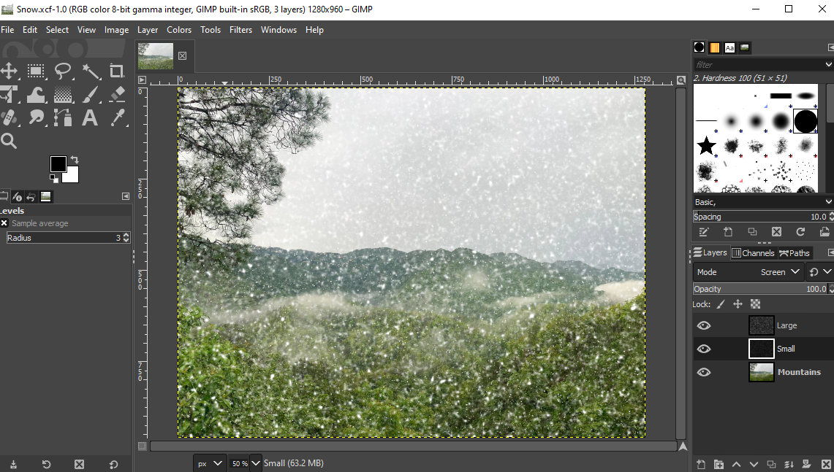

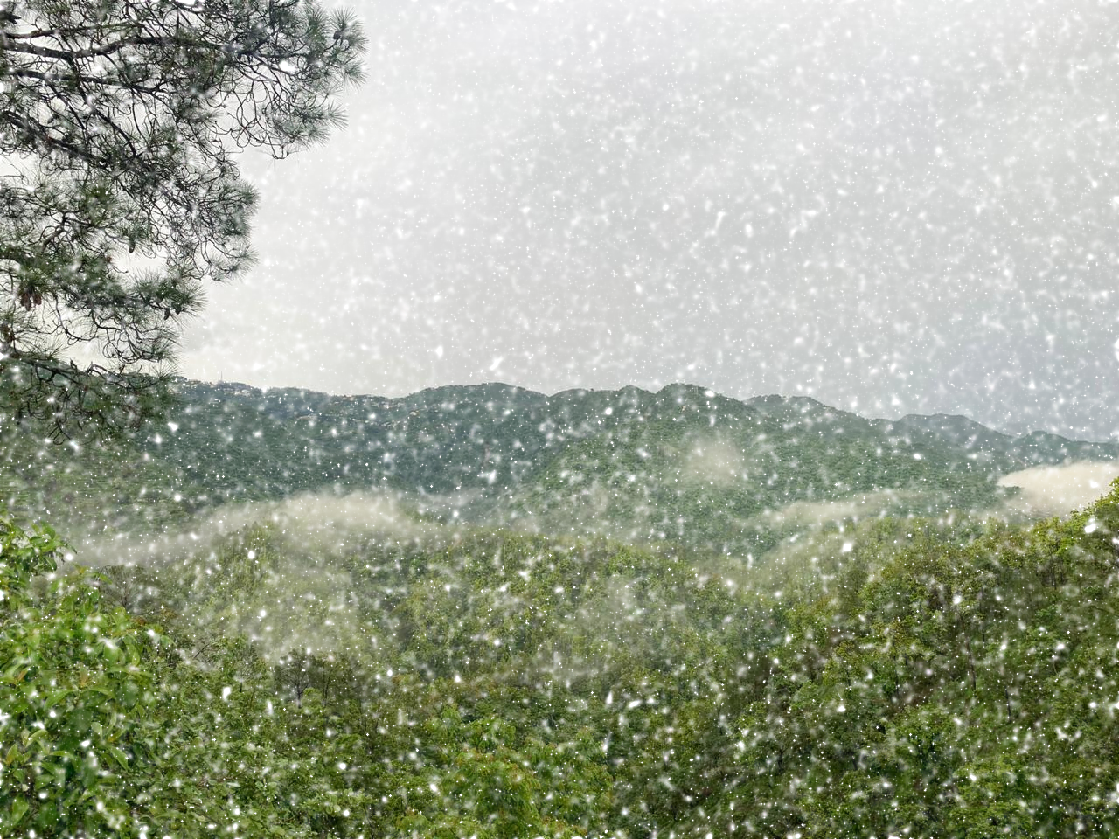

**Objective 2:** To design a skyscraper using blender.

**Procedure:**

**Step 1:** Open Blender. Create a blank file.

**Step 2:** Add a plane and scale it to an average area of a building, using Shift+A>S.

**Step 3:** Switch to edit mode using TAB.

**Step 4:** Add some loop cuts using Ctrl+R, to create a division of rooms inside the hut. Loop cuts are needed to be added with respect to X and Y axis.

**Step 5:** Now, delete any one face on any level to bring the plane in L shape and extrude (E) it with respect to the z-axis such that it is equal to the six floors.

**Step 6:** To make a dome on the roof, extrude from corner from one of the ends of the building block. Add a similar plane in between both floors to differentiate between them.

**Step 7:** Next, add some pillars to the building by adding a plane first and then by scaling it with respect to z-axis. Now add the same pillar to every corner by just duplicating it. (Shift+D)

**Step 8:** To create the windows, add a frame apart from the frame for the building. Extrude the window according to how much depth you want. Now duplicate it using (Shift+D). Now, add an array modifier (x-axis) and increase the number according to the length of the roof. Add a second array modifier (y-axis) and increase the number according to the breadth of roof.

**Step 9:** Add the stairs to building by using add-on and then, use any of the textures to provide a brick layout for the building.

**Step 10:** Now, add a camera and a light source to it. And arrange the camera to the best fit view.

**Screenshots:**

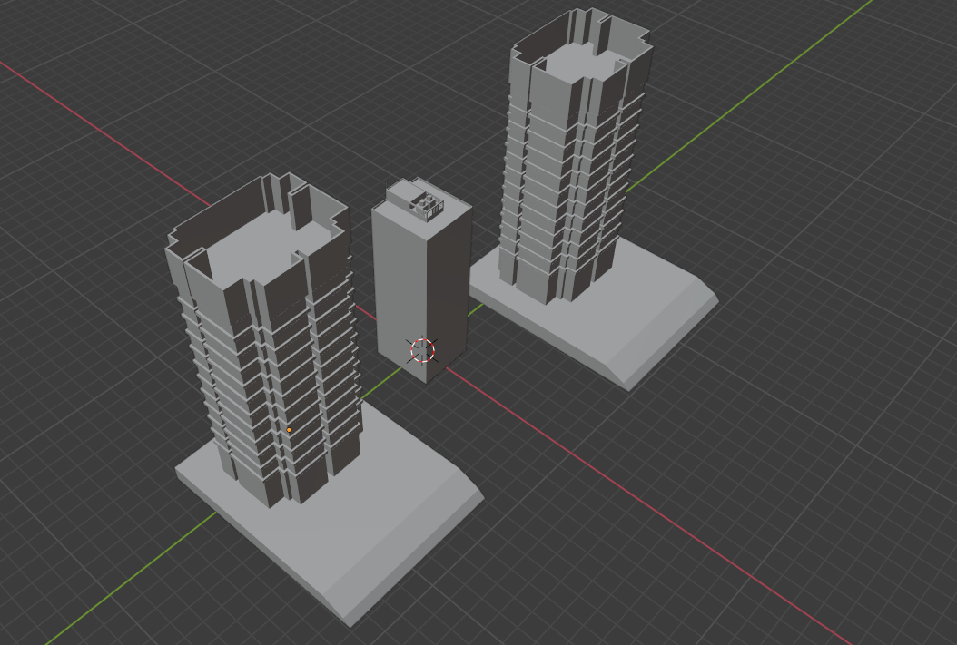

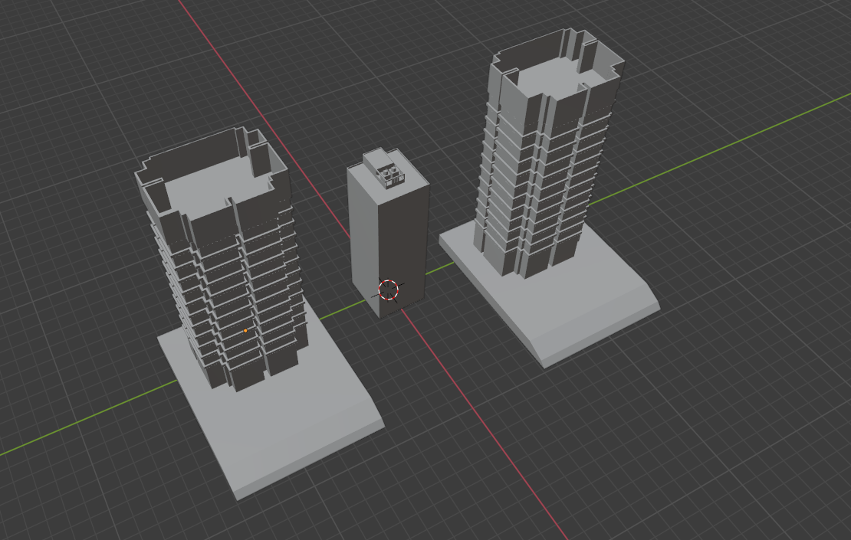

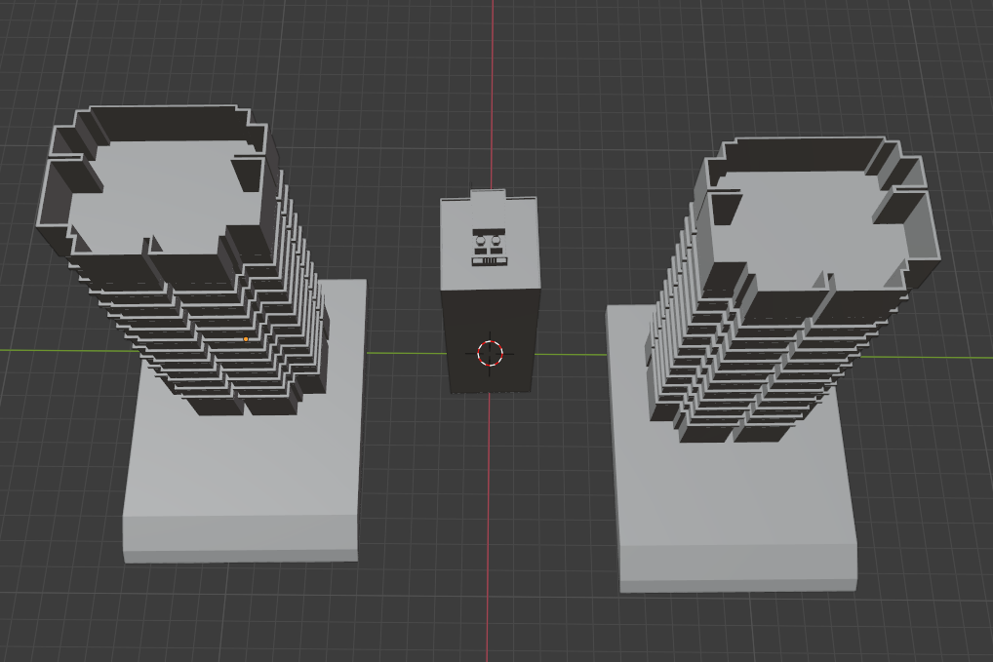

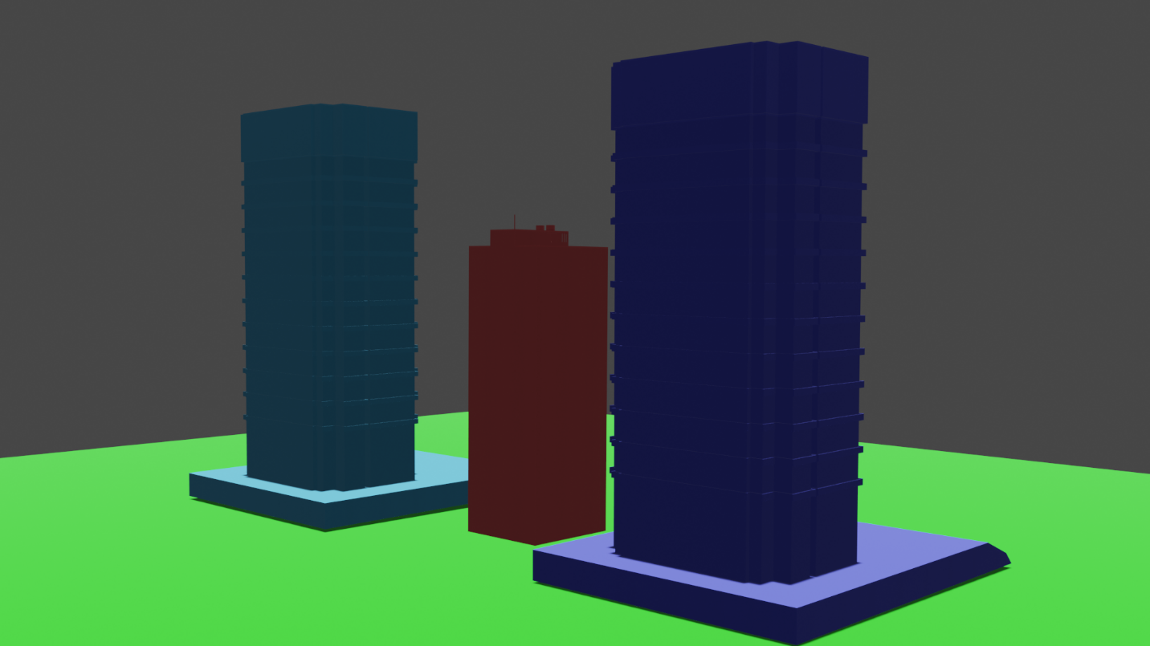

**Link:** [Viva Assignment 2](https://drive.google.com/drive/folders/16IGq-sZZojYvq70x90Ft6EwtbvLKuxjS?usp=sharing)